Randwick Village Hall Dishwasher Instructions v3 23/1/23

- Power on machine at wall switch.

- Open door and check drain plug is in place.

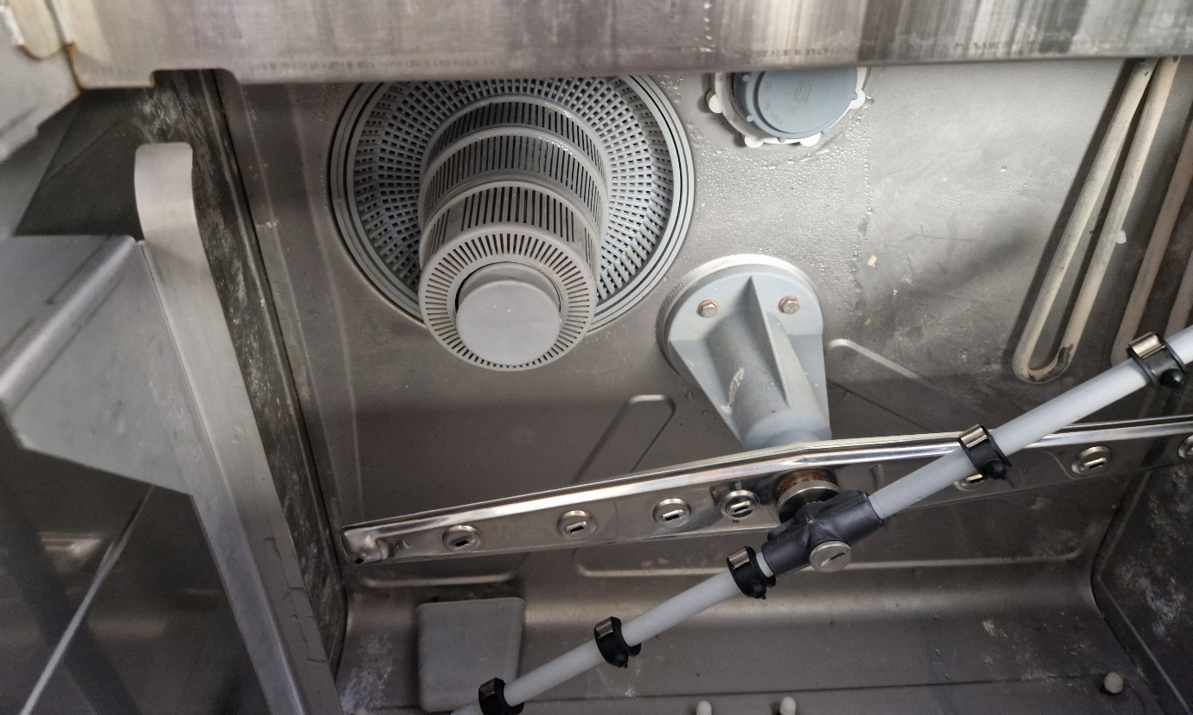

- Close door and press start button

When this button is first pressed the machine operates through a sequence of filling the tank with water and heating it up. This may take 30minutes. The rinse temperature must
be min 85degC and tank temp min 55degC.

- Once at temperature load the machine.

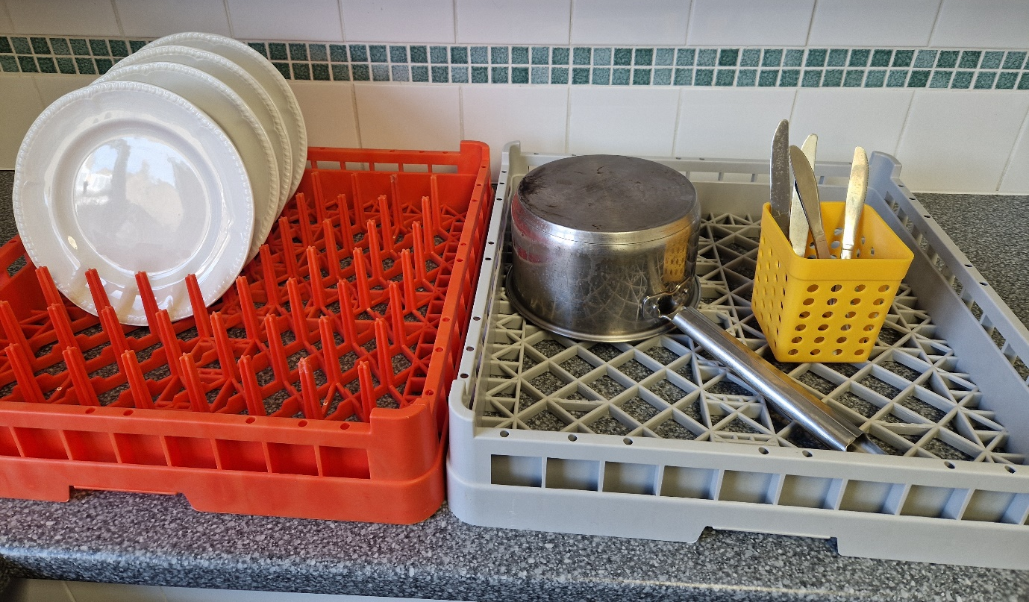
Cutlery
Pans
Crockery

Note: this is not a waste disposal unit and any solid waste should be rinsed off in the sink before loaded in the washer.
5. Close the door and select your wash time by using one of the three buttons on the right side of the control panel. They require a short press to activate the wash cycle.
Button 1 Short wash (90s)
Button 2 Medium length wash (120s)
Button 3 Long wash (180s)

180s
120s
90s

- When the wash cycle is complete open the door, unload and reload and restart the cycle (step 5).

- Once you have finished with the dishwasher open the front door and remove the plug ready for the drain down cycle.

- With the door open hold button 1 down for 4 seconds, the button will flash, and the water will drain away slowly.

- Once empty rinse out the bottom of the machine with a jug of fresh water.

10. After it has drained remove the filter and rinse solids down sink.
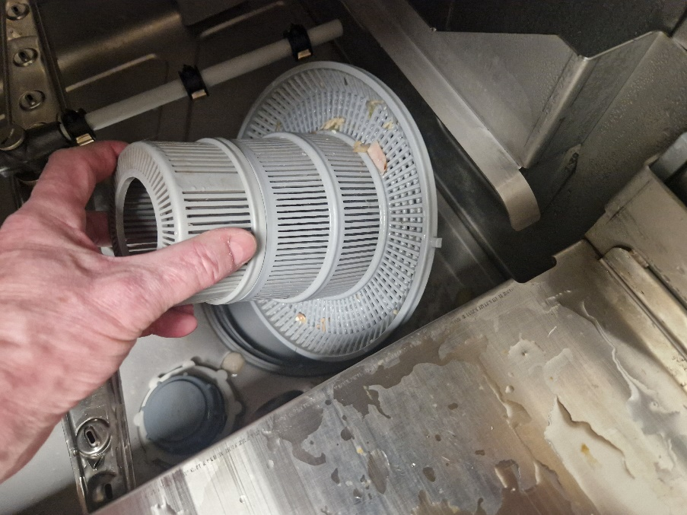

- Replace the filter and drain plug and power off.

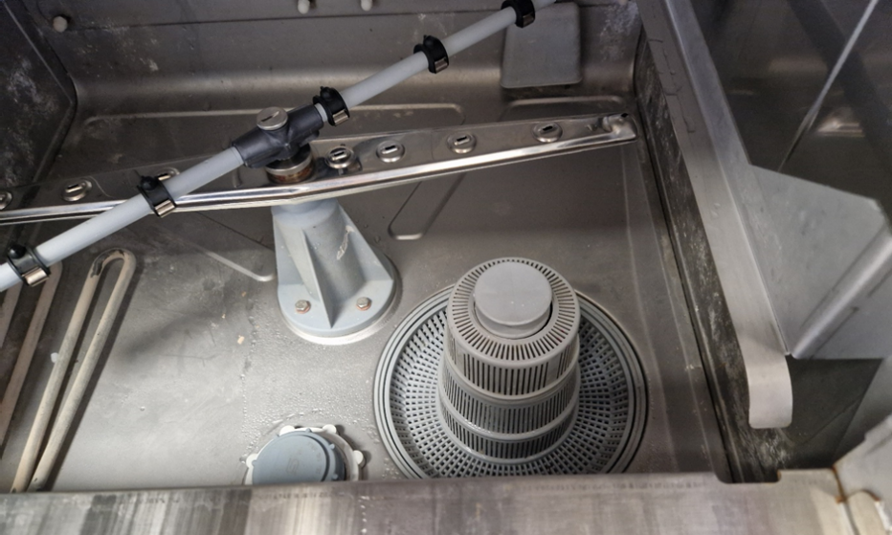

- Leave the door open to dry the machine out.

Switch off at the wall after use!

